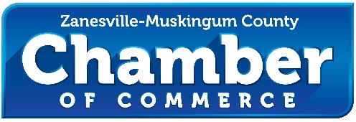

November 5, 2023

Martin Luther King Scholarship Fund
Zanesville, Ohio

Re: Letter of Support

Dear Mrs. Brantley,

The Zanesville-Muskingum County Chamber of Commerce writes this letter in support of the local Martin Luther King Scholarship Fund whose mission is to seek, create, and provide quality programs that reflect the life and teaching of Dr. Martin Luther King Jr. by communication and direct instruction programs designed to meet the challenge of an ever-changing world.

The committee plans to engage the high school scholarship recipients via the following topics.

- Interview skills workshop with the local employers and employment service agencies
- Workforce and Vocational Awareness for jobs not requiring a four-year degree.
- Navigating the collegiate financial sector
- Developing financial tools for a lifetime of success
- Professional development- etiquette, dress for success and more!

Our organization will assist with the activities by convening the local committee and entities in our community for the betterment of local students.

Respectfully submitted,

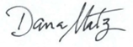

Dana Matz
President

